

Partnership for Mother Tongue-based Bilingual Education in Ghana
P. O. Box 47, Gambaga Northern East Region. Ghana

New KG1 Students
Our newly enrolled KG1 students formally joined La'angum Learning Centre on September 2, 2025. The class has 17 boys and 23 girls. Mary Azure, Mahami Wuni, and Azumah Bugri are the classroom teachers of this great class. During their orientation, the teachers introduced the students to the school’s facilities: the WASH Project, Kitchen, Water Tanks, Playground Equipment and the school environment. As expected, some children cried and felt uncomfortable in the first week of school reopening, but as the days passed, they began to acclimatize and feel more at ease. The KG1 teachers will soon hold a Parent-Teacher Conference for the new parents. As part of the admission requirements, school fees and half of the food contribution were paid by our new parents. Children aged 4-6 years old are eligible for admission to KG1. The new KG1 students have settled down well in class and progressing with their lessons at LLC.Most parents from Langbinsi and Tangbini bring their children to school and pick them up after close of school.
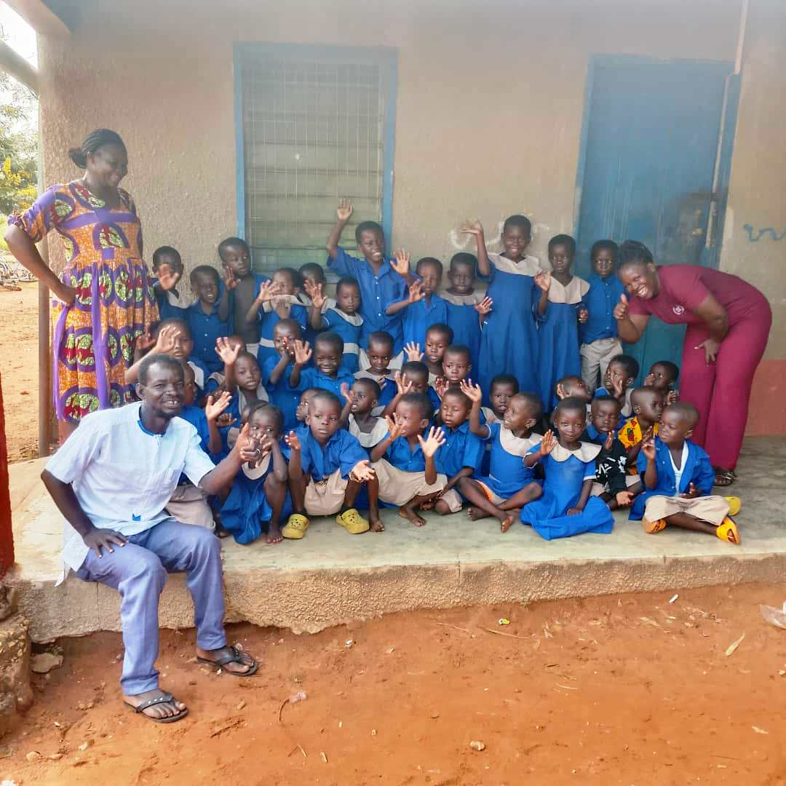
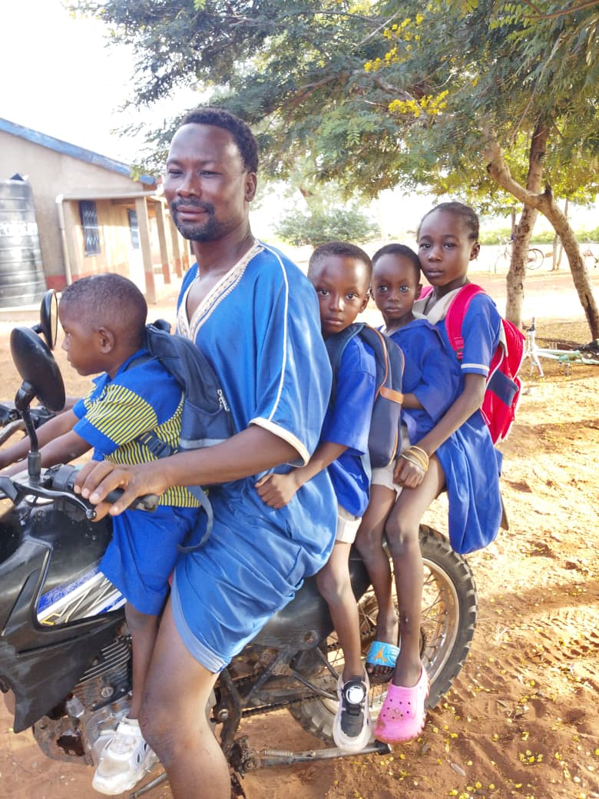
A parent transporting his children after close of school
KG Teachers and their Pupils

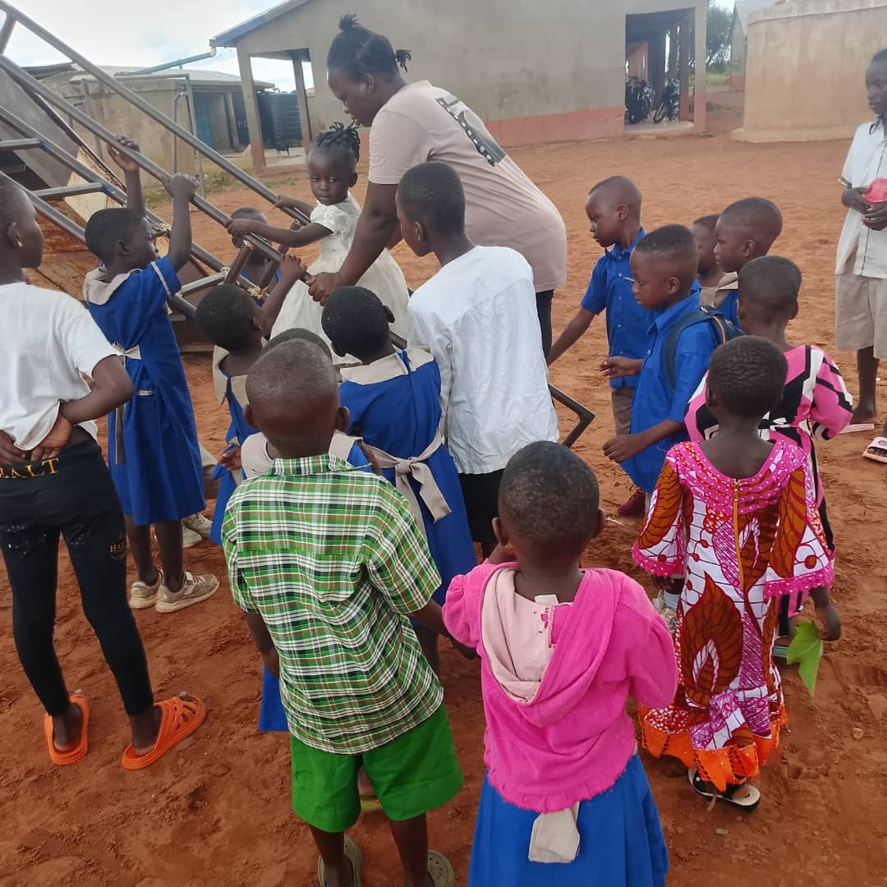
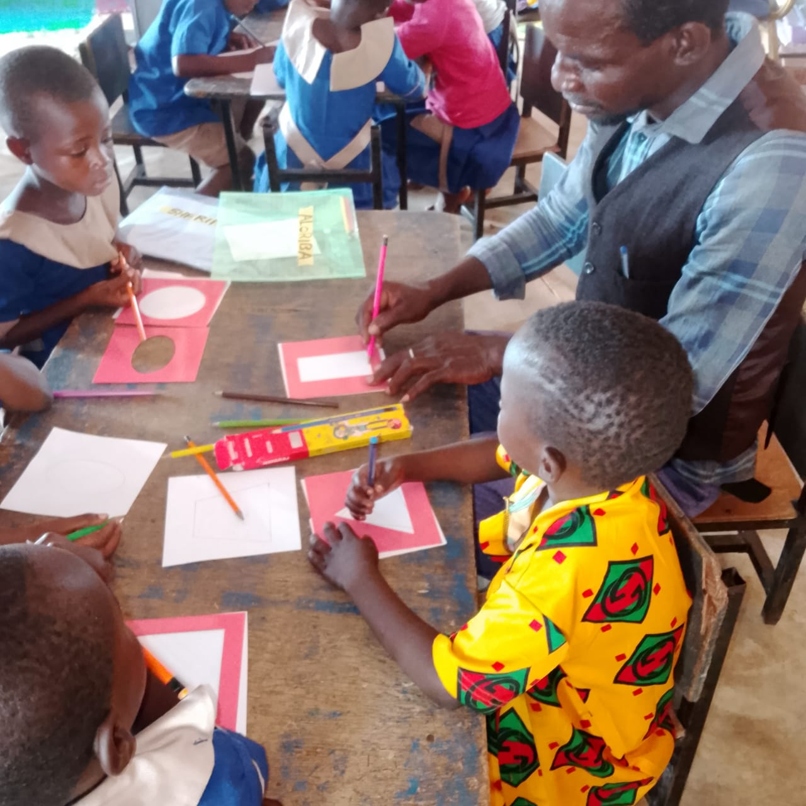
Mahami and his students
Madam Azumah leading students on how to use playground equipment

First P.T.A Meeting
On the 15th of September, 2025 we held our first PTA meeting for the term. PTA Chairman, Secretary, Treasurer, Community Leaders, Food Collectors, Head Teacher and other executives members were present during the meeting. Parents from Bunboazio, Langbinsi, Tangbini and Bantambari were also present during. After the opening prayers, we observed a moment of silence to honor the memory of one of our dedicated parents, Malam Abass who passed away during the vacation period. The Secretary read the previous minutes of the last meeting held. Among other issues discussed, the new school fees, deadline for the contribution of groundnut , the new academic calendar, introduction of new P.D, New Head Teacher and Assistant and others. Parents enquired about the state of the new biogas plant, fortunately the biogas operator was at the meeting, he updated parents on its status. Parents were very happy to hear about the update and waiting anxiously for its full operation.
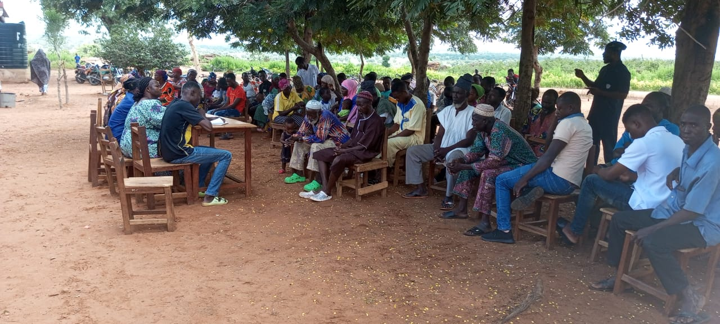

PTA Meeting in Session

PTA Meeting in Session
MY EXPERIENCE WITH THE 6-12 MONTESSORI ORIENTATION COURSE IN DAKAR.
The 6-12 Montessori Orientation course in Dakar was a wonderful experience. Our Trainer from India was warm, sociable, and effortlessly connected with everyone. She introduced herself, sharing her extensive training experience and insights from working in various settings, including her own Montessori school. Her stories of challenges and successes with parents and students added valuable context.

THE COURSE COVERED KEY TOPICS, INCLUDING:
- The history and philosophy of Dr. Maria Montessori
- Human needs and tendencies.
- Practical Montessori lessons in the practice room.
- The four planes of human development
- Cosmic education, including a dedicated reading seminar.
- Prepared environment, and the role of the adult.
- Observation Techniques, interacting with elementary children, and exploring freedom and responsibilities.

I was particularly impressed by the breadth of topics and materials presented. Having participated in other Montessori workshops, I felt that this course provided a comprehensive and engaging experience.
The orientation course has been enlightening, deepening my understanding and knowledge of how to support and nurture children's development. I have gained valuable insights into the absorbent mind of children, which is hungry for knowledge and retains up to 90% of what they learn during this stage.

A prepared environment that caters to their needs and tendencies enables children to communicate confidently, adapt to new settings, and become independent and self-reliant. In contrast to traditional education systems, children nurtured in this way tend to thrive.
The importance of timely learning experiences, such as introducing writing and language skills at the right age. For language development, the 0-4 age range is crucial for learning grammar and language fundamentals.
Whiles I have attended various Montessori workshops, this 6-12 orientation course has provided a unique perspective, broadening my understanding and strengthening my commitment to the Montessori Methods of Education.
This course has been valuable in my new role as Program Director, and I am confident it will positively impact the future of LLC. While many of our teachers have attended Montessori workshops, this experience has highlighted the difference between attending workshops and being trained to implement a Montessori curriculum effectively.
I strongly believe that prioritizing Montessori professional courses, particularly Diploma Programs is crucial for our dear LLC. Although we have explored sending teachers to the USA for training in the past, visa challenges have hindered our efforts. In view of this, I suggest exploring alternative training options in other parts of the world, including Africa.
Comparing the knowledge gained from this course to our current practices, I am proud of what we have achieved at LLC. However, I recognize that we need to focus on enhancing professional teacher training and acquiring more materials to reach our full potential. I suggest we purchase some key Montessori textbooks such as The Absorbent Mind, Citizen of the world, The Four Planes of Development, From Childhood to adolescence and others
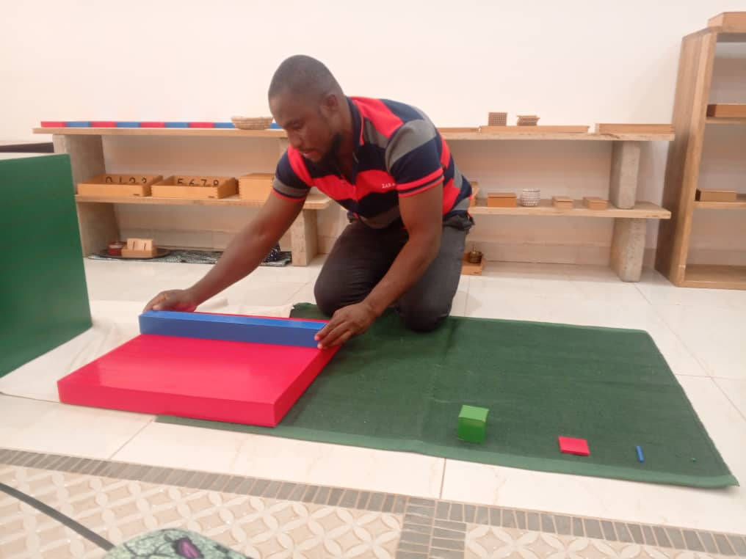
Majeed practicing with Montessori Material

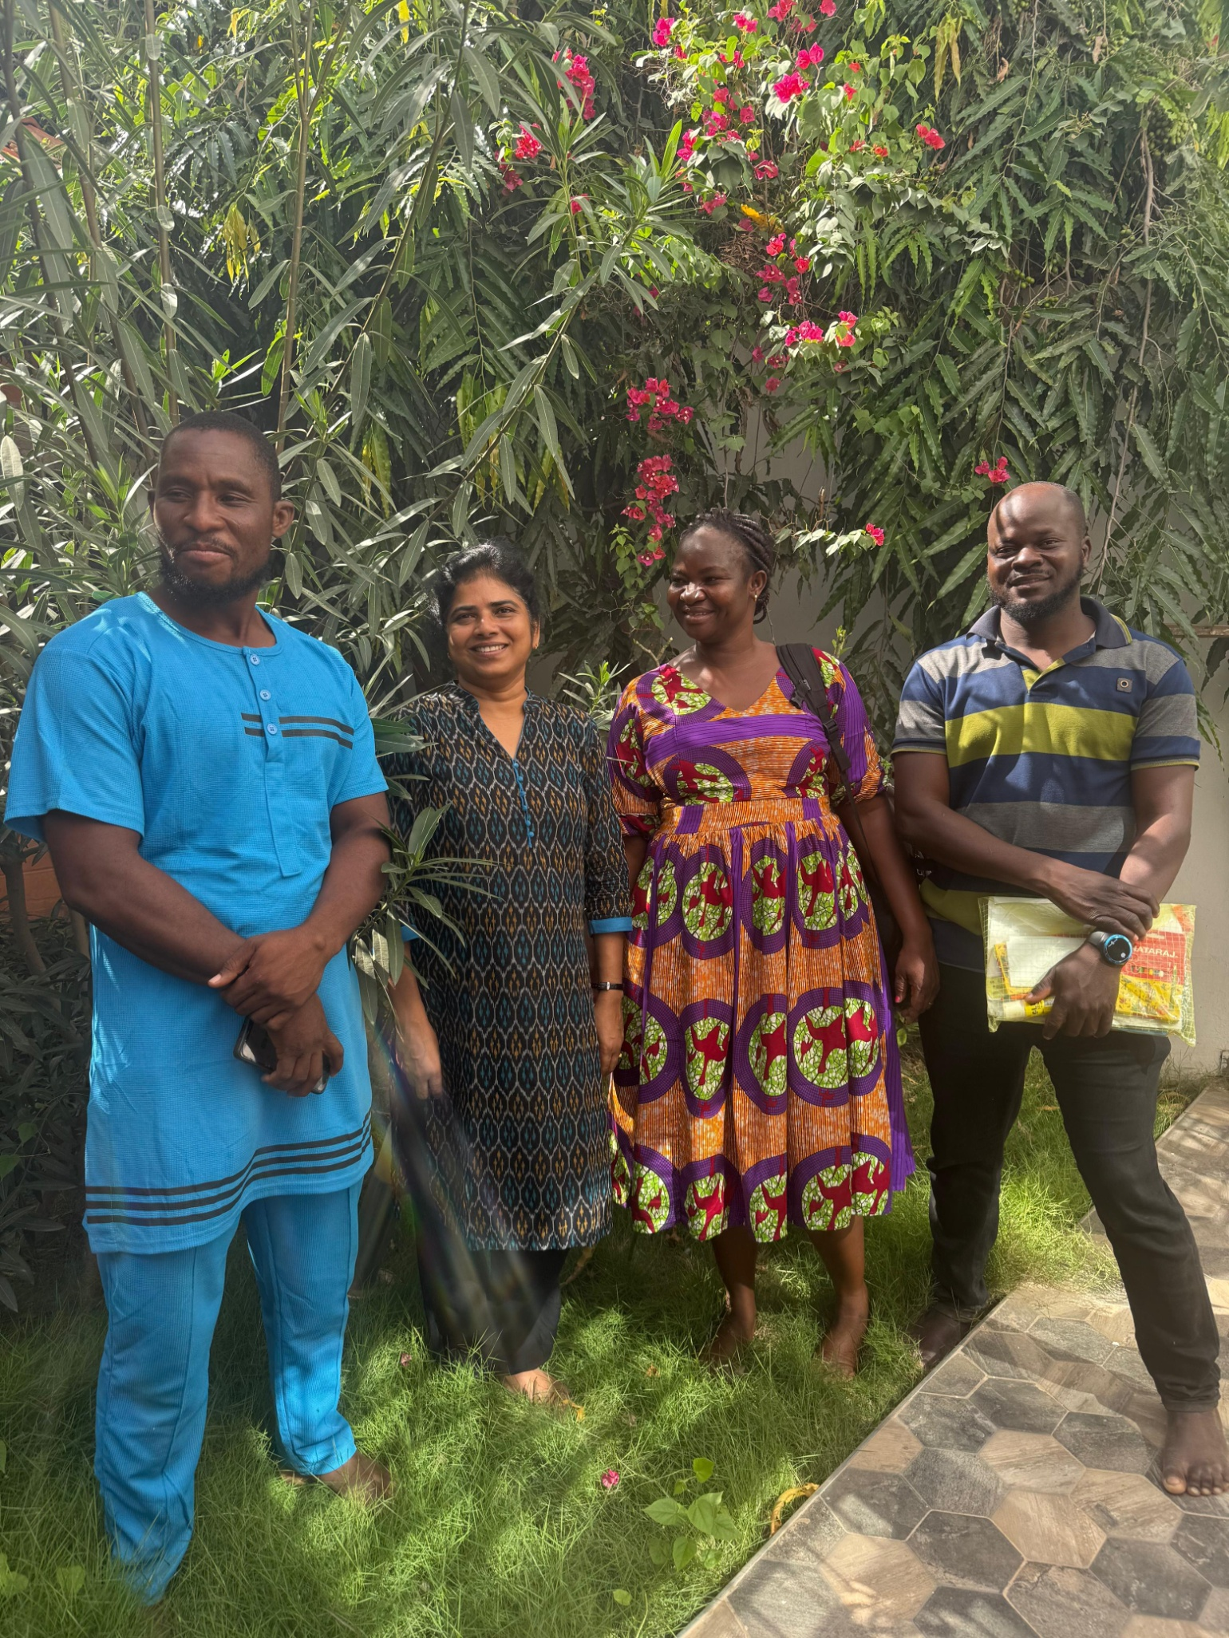
Majeed,Robert and Mary with their Trainer in Dakar

Engagement with staff members after Dakar

Upon our return from Dakar, Fidelis and I met with the leadership team of LLC and expressed sincere gratitude to the Acting Head Teacher and the supporting team members for their exceptional leadership and management of LLC in our absence. We appreciated their dedication to maintaining stability and continuity. The team provided a comprehensive briefing on key developments and activities that took place during our trip.
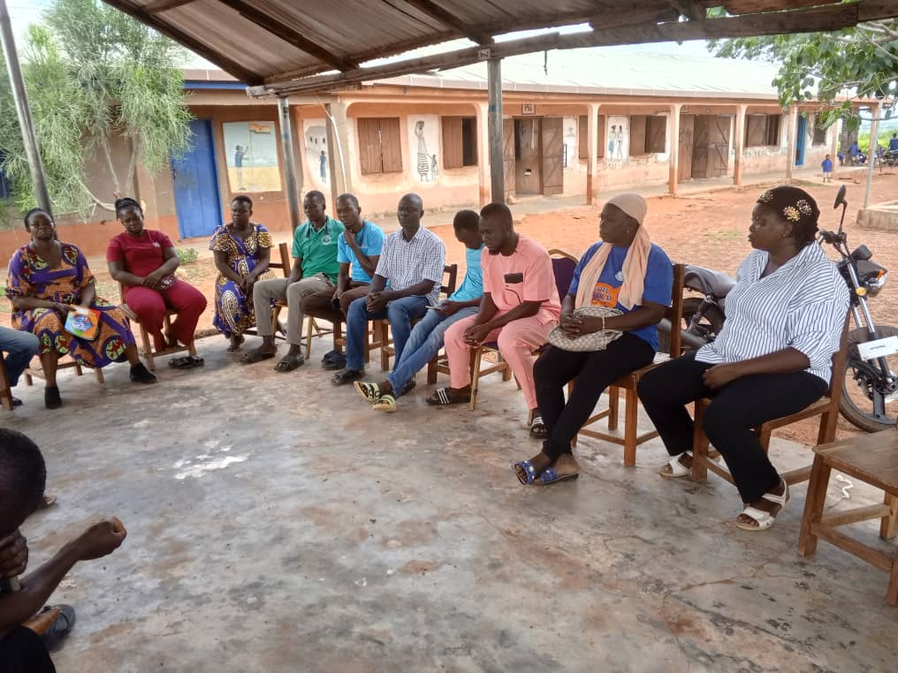
We also met with the general staff members to extend our heartfelt thanks for their hard work and commitment. We shared highlights from our Dakar experience and look forward to more detailed knowledge-sharing sessions next week, specifically tailored for both Lower and Upper Elementary staff members. The interactions were enriching, and we appreciated the opportunity to reconnect with the team after our return.

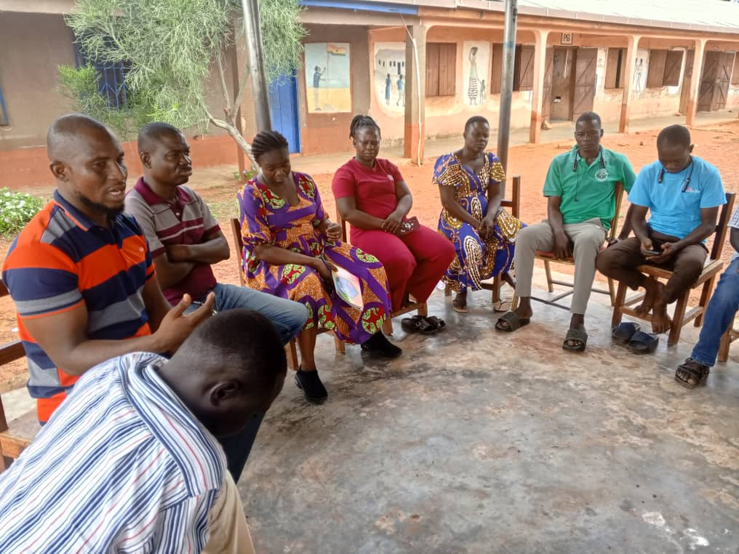
Staff Engagement after the Dakar Trip

Reinstatement of Baani Wuni

Baani Wuni who until recently was the Lunch Coordinator, was involve in an accident some time ago. This accident has severely impacted his mobility and work. During Alice tenure as the Acting Programme Director, it was suggested that due to the his deteriorating health condition, he should be considered for early retirement so that he can depend on his monthly Social Security benefit and other entitlement.

The process for the early retirement started, medicals was done but when Wuni went for the final medical screening by the medical team from the Social Security they declined to accept the reasons for that decision. Their reason was that the monthly Social Security that will be paid to him by government will be inadequate and as such if we feel we are not getting the best from his schedule he should be reassigned.

Whiles awaiting for the final response from the Social Security medical Team, Wuni’s monthly Social Security, Income Tax and Tier 2 contributions were halted. He will be reinstated and those statutory deductions will commence this month in addition to enrolling him onto the Provident Fund.

Currently Azumah Bugri has taken over from him as the Lunch Coordinator while Wuni has been reassigned to the School Library.

