

Partnership for Mother Tongue-based Bilingual Education in Ghana
P. O. Box 47, Gambaga Northern East Region. Ghana

Field Report For September 2025
Teacher Training
Prior to school resumption, all LLC teachers participated in a three-day Jolly Phonics training workshop organized by the outgoing P.D. The training introduced Jolly Phonics, covered letter sounds with demonstrations, and included activity-oriented sessions. Teachers were grouped into four to improvise classroom materials, and each group presented their work. The facilitators provided feedback and suggestions, and all agreed that the training was worthwhile. Key takeaways included the need to:
- Extend the training duration to five days
- Consider expanding training to upper primary subject areas
- Emphasize discipline, hard work, and practical application
- Combine theory with access to teaching materials.
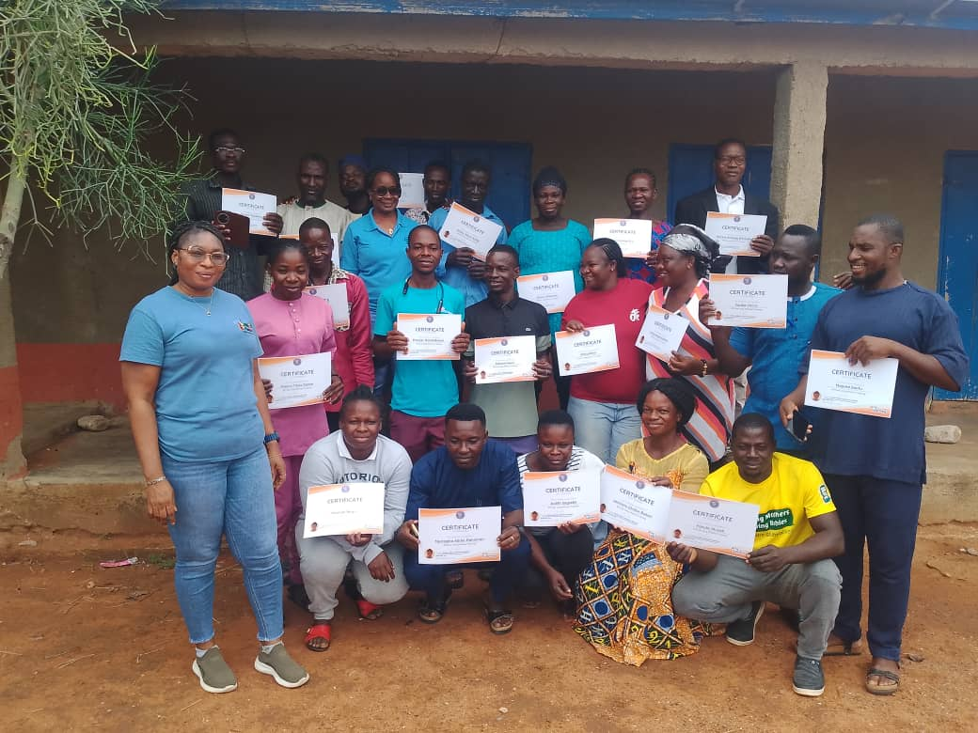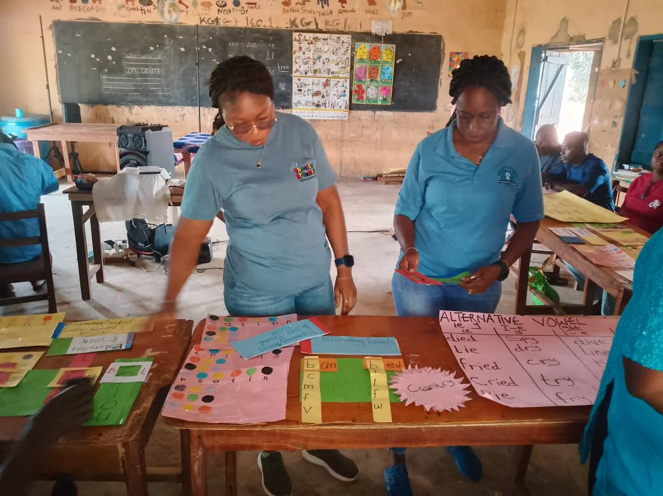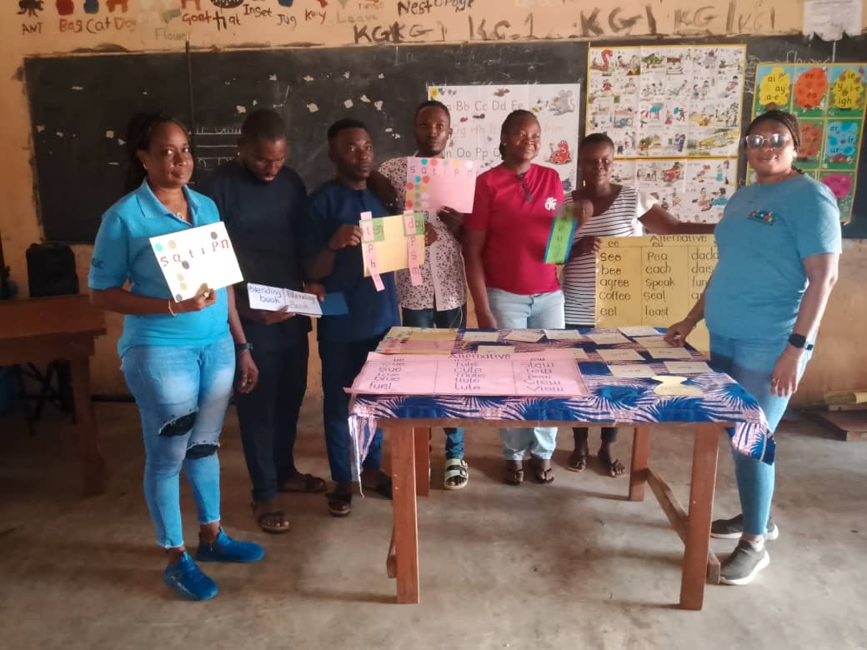

PICTURES FROM JOLLY PHONICS TRAINING WORKSHOP

Water Extension Project
On August 22, 2025, Mr. Kumah handed over the water extension project designed to provide sufficient water for the WASH project and the teacher’s quarters. Key stakeholders who attended the handing over ceremony included the PAMBE Ghana Advisory Council Secretary, LLC PTA Chairman, LLC Water Committee representatives, the Head Teacher, Assistant Head Teacher , Accountant and Programme Director.
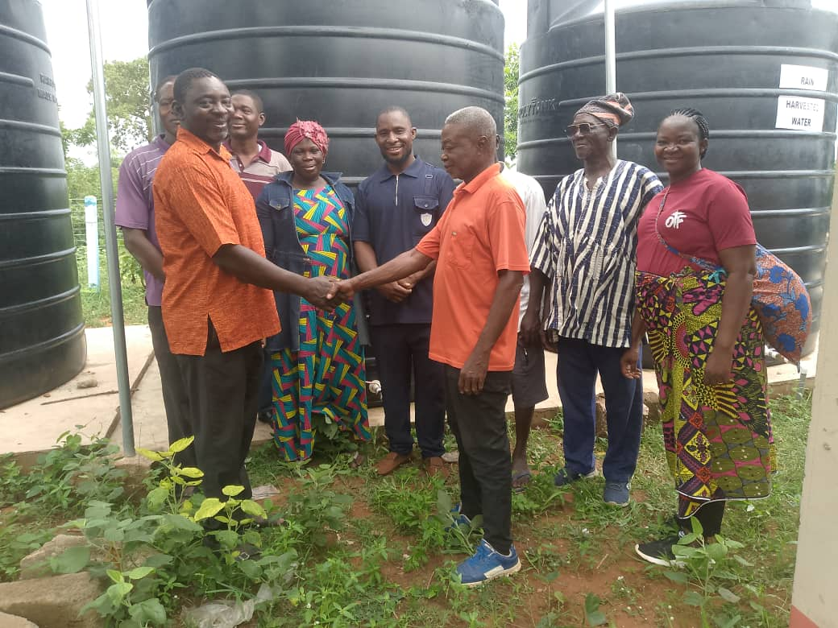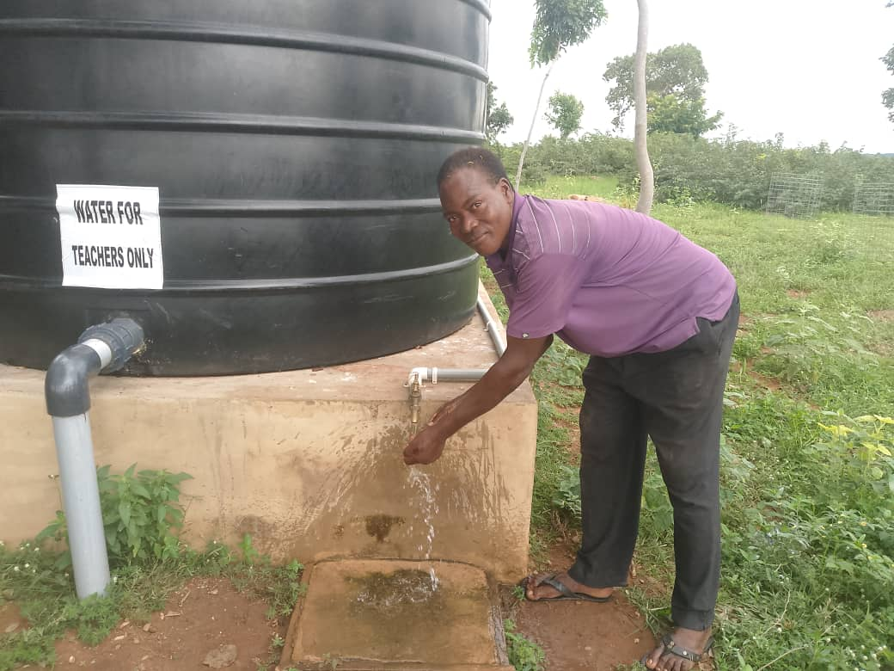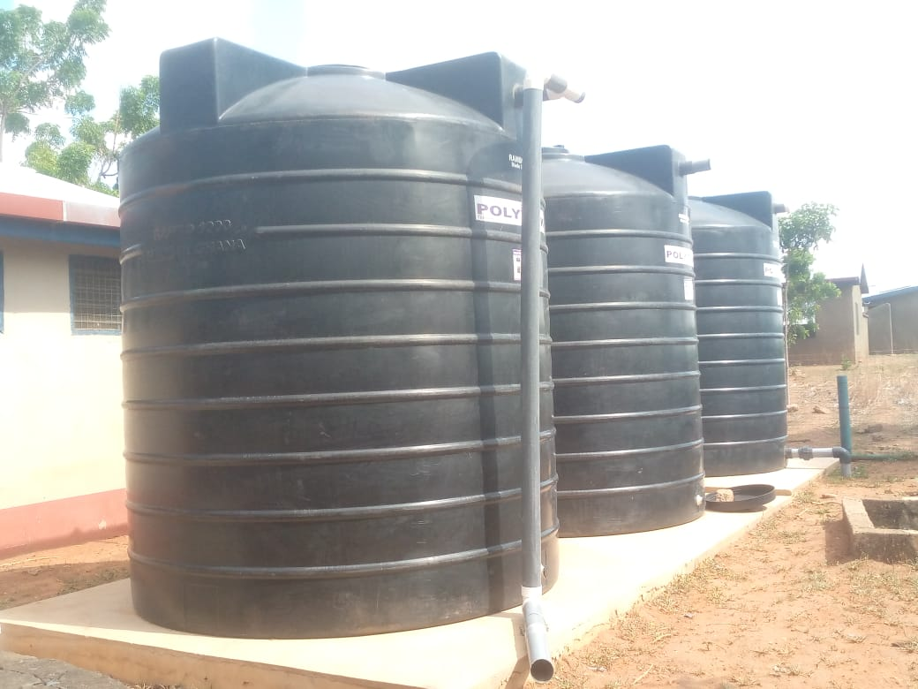

HANDING OVER CEREMONY OF WATER PROJECT

New Academic Calendar
The First Term began on 2nd September and will end on 18th December, 2025. As usual, the first week focused on cleaning and arranging classrooms, and the environment. The Head Teacher and Assistant distributed school supplies to teachers for their students. Teaching and learning is currently ongoing in LLC. Accountant and I met with Head Teacher and her leadership Team and later the other staff members of LLC. We discuss among other things the need to co-operate and support the new Departmental Heads and Leadership Team to achieve the intended outcome. The2025 LLC graduates have been sent to their new school (Unity JHS) for further studies. The PTA executives held a meeting and decided to hold the first PTA meeting for the term on the 15th of September, 2025.
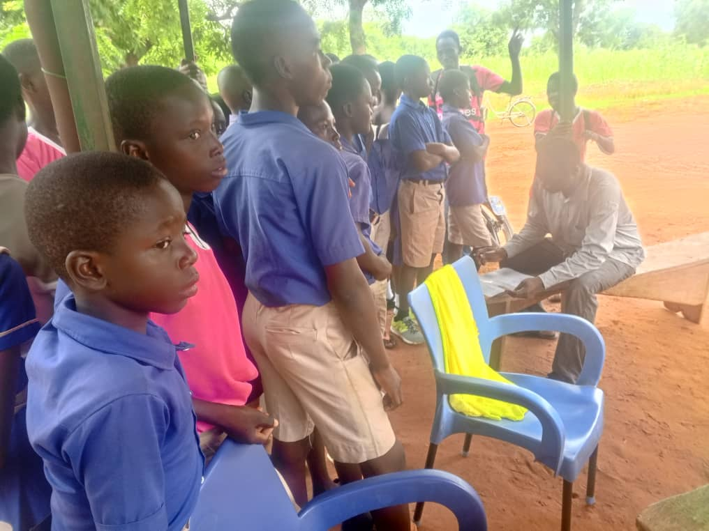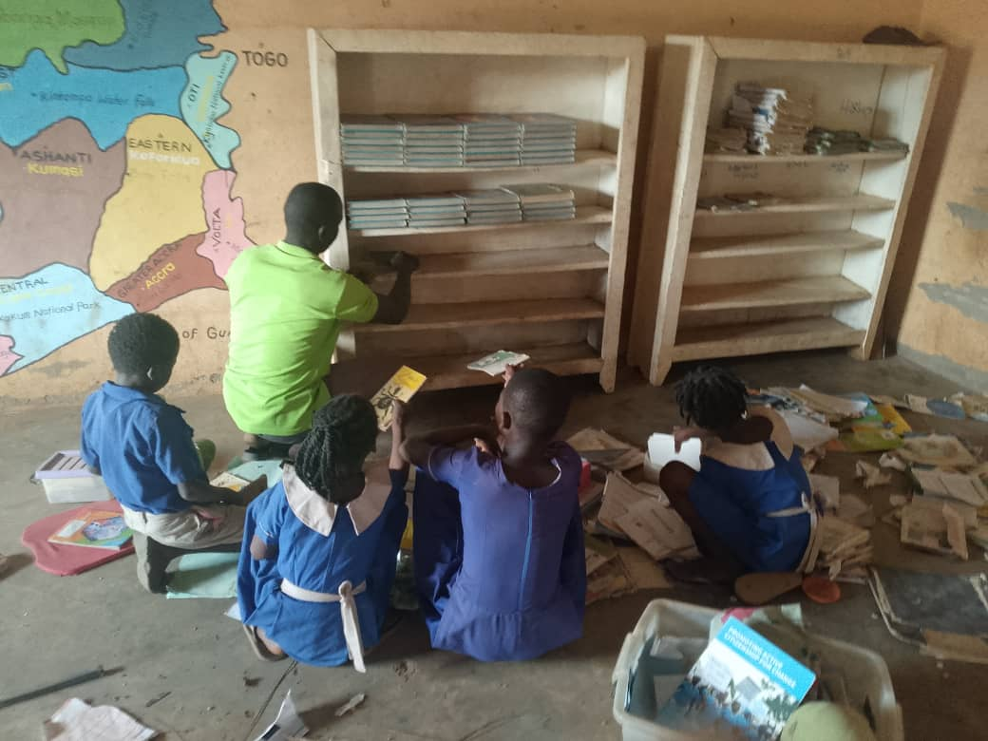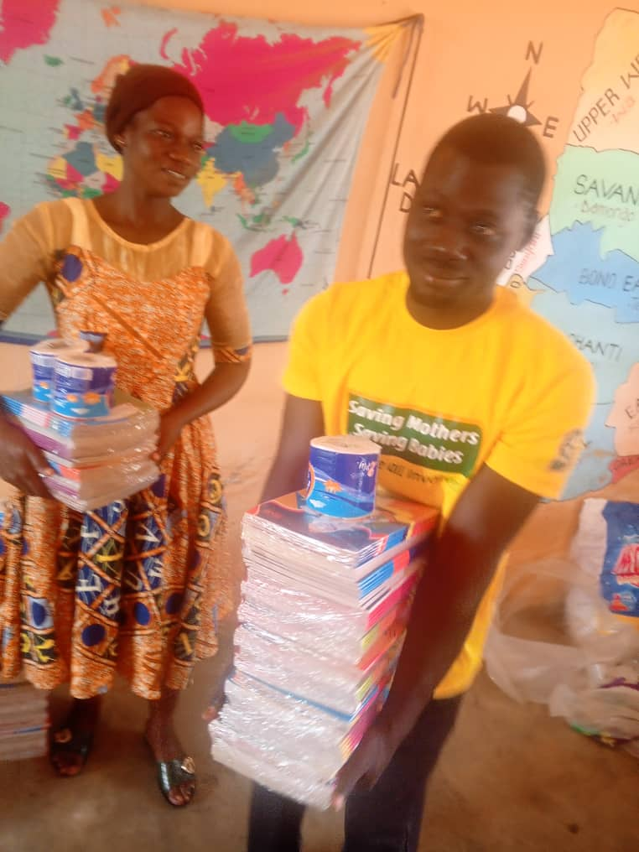

2025 GRADUATES,STUDENTS CLEANING CLASS AND TEACHERS RECEIVING STATIONERY

Continuing and new Students and Updates
Six (6) new transfer students from Bantambari have been admitted into LLC. Negotiations are underway for the Ghana government to absorb the Bantambari School into the public school system. Most of our continuing students in LLC have resumed from the long vacation. All teachers are at post. The annual commitment fees (Tuition Fees) for LLC students have been increased from GHC120.00 to GHC150.00 effective September 2nd, 2025. Madam Azumah Bugri has been re-assigned as the new Lunch Coordinator of LLC due to Wuni Baan's current health condition.

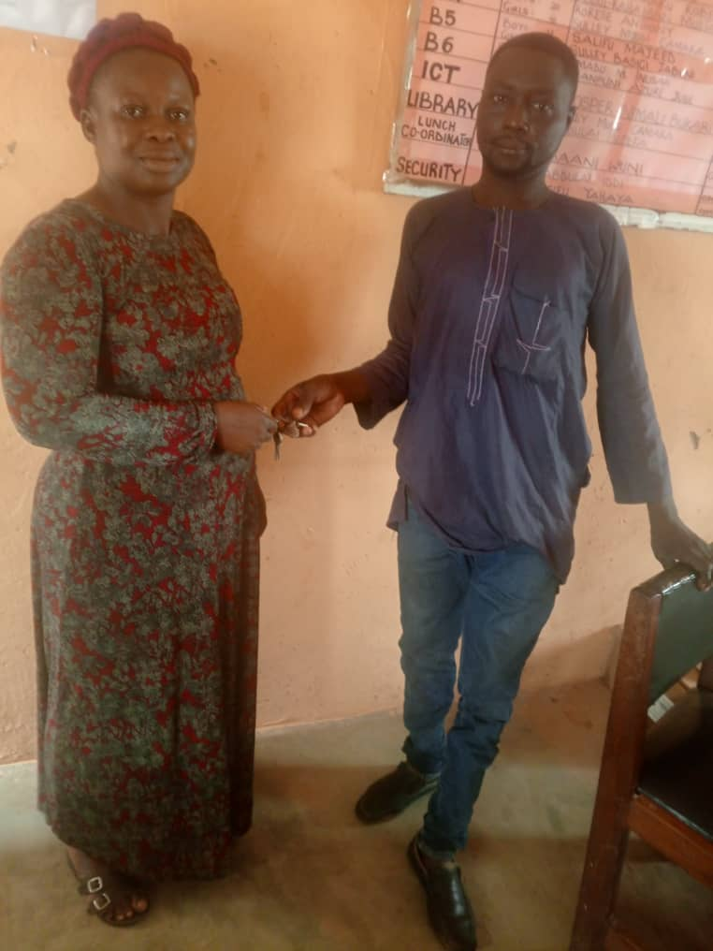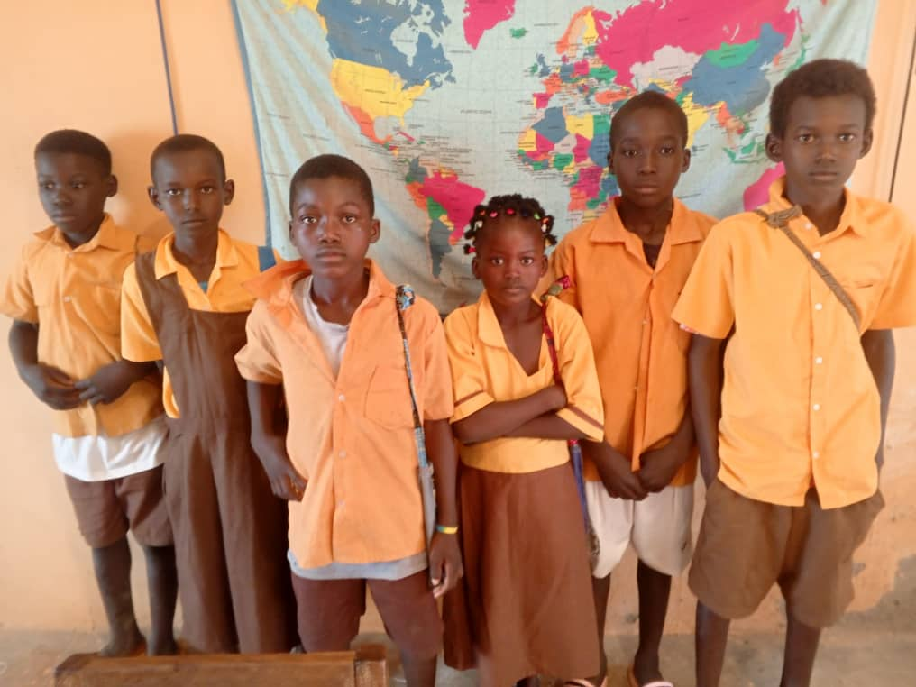

MADAM AZUMAH TAKING OVER FROM WUNI AND NEW STUDENTS FROM BANTAMBARI

Steve and Son’s Visit to LLC
On the first day of school reopen for the 2025/2026 academic year, Steve and his son paid LLC a visit. They first visited PAMBE Ghana office in Langbinsi to exchange pleasantry with the office staff before proceeding to school to meet with the teachers and other staff members. They were welcomed to LLC by the new Head Teacher madam Mary who took them round the school by visiting each classroom, Library, ICT lab, kitchen, Teachers Quarters, WASH Project and the new Biogas Plant. Afterwards there was a staff durbar to introduce Steve and his son to the staff. Steve then introduced the new Programme Director in the person of Majeed Salifu to staff and admonished them to give him the maximum support to succeed in his new position. He also paid a courtesy call on the Bumboazia Chief and the Langbinsi Chief together with the Advisory Committee Vice Chairman, Accountant and Programme Director.
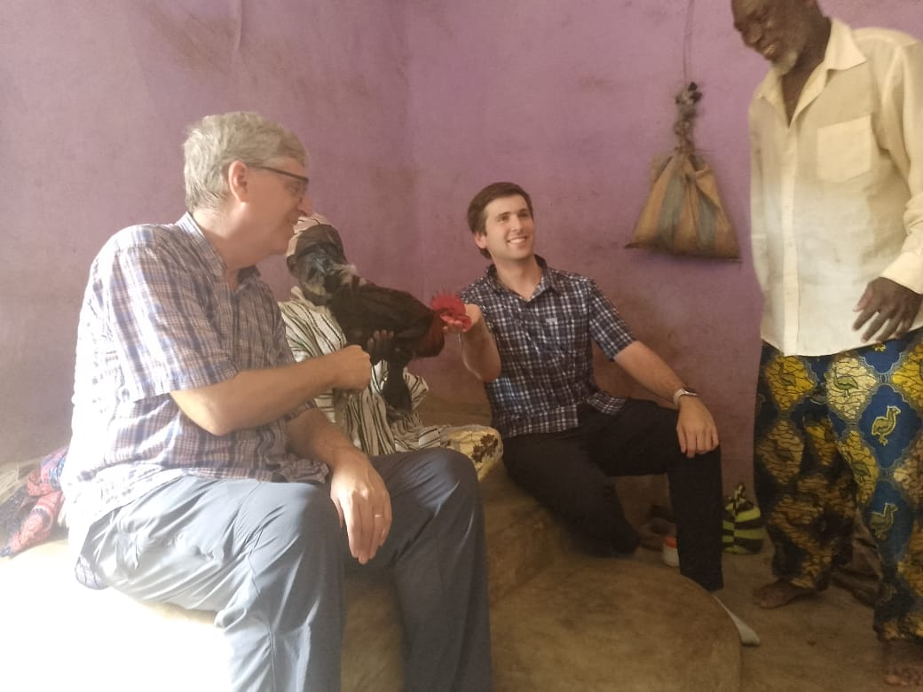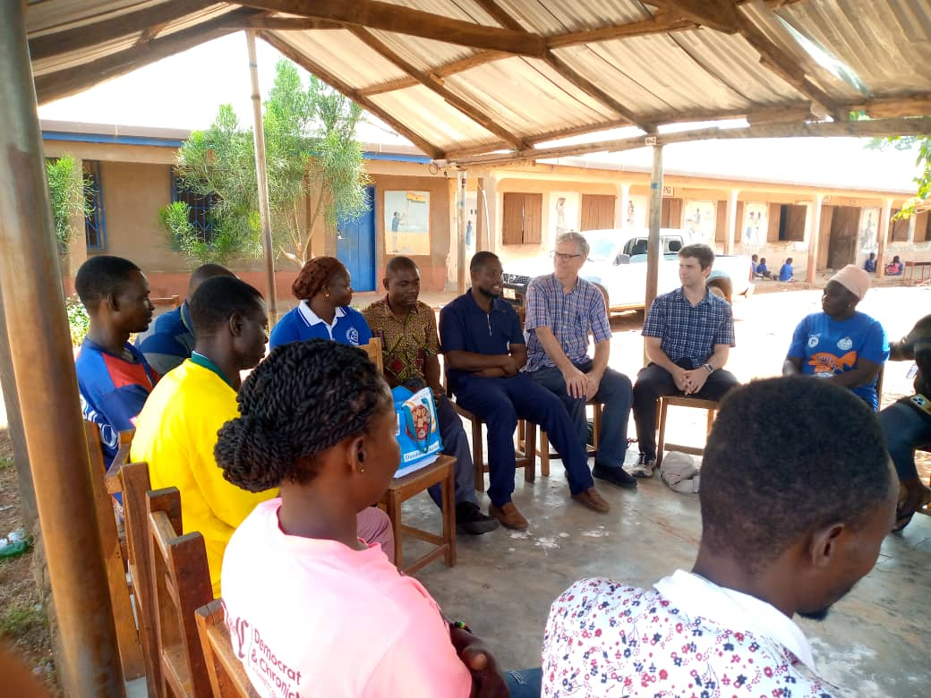

STEVE AND SON VISIT TO LLC AND BUMBOAZIO CHIEF’S PALACE
Biogas update.
The biogas operator and engineer confirmed that the supersonic metallic tank produced sufficient gas. However, the engineer advised pausing further feeding to prevent potential explosions caused by accumulated unused gas. Next, we will test the existing kitchen stoves and work on the biogas purification chamber. The purification chamber is crucial for removing impurities, such as carbon dioxide and hydrogen sulfide, from the biogas, making it safer to use. It also reduces corrosion of stoves and other kitchen equipment. This subsequently reduces the risk of toxic gas leaks and explosions. Thus, funding is needed for this key piece of equipment in order for the biogas to become fully operational.

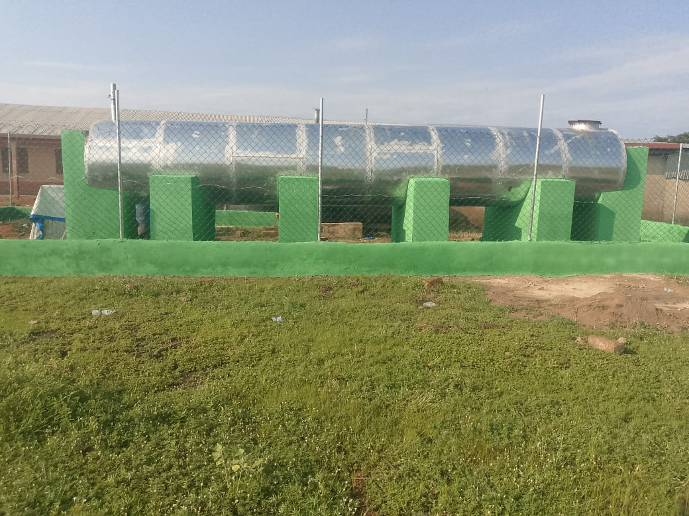
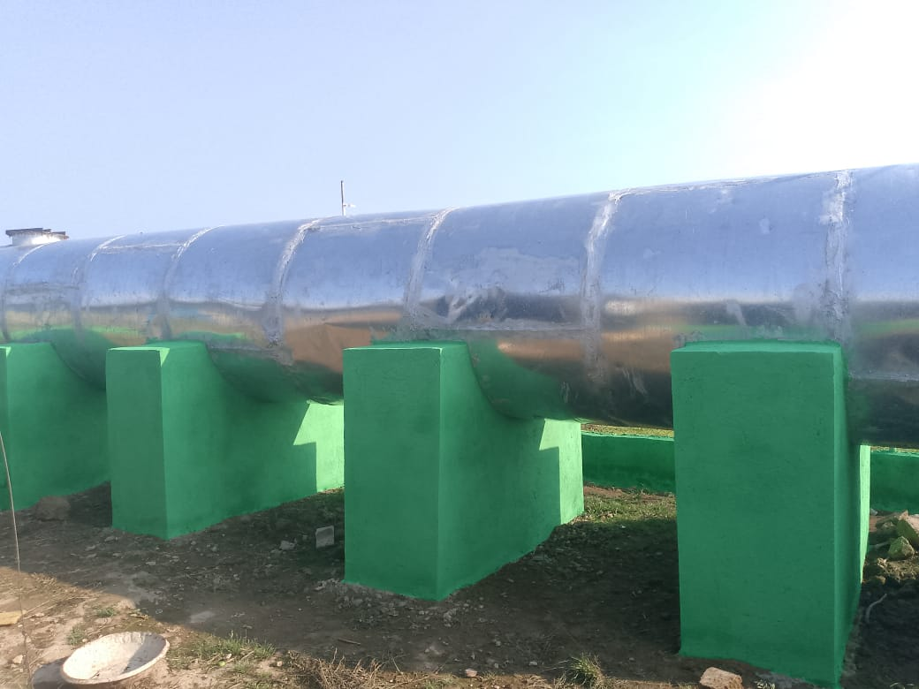
The biogas engineer, who was hospitalized in Tamale for a week, has been discharged and is recovering at home. He's feeling better, although he's not fully recovered. He plans to return to Tamale for a review. Once he has fully recovered, he will update us, and we will make arrangements to finalize the project and ensure the kitchen's full biogas operation
BIOGAS PICTURES

